**Kürvers Piping Website Copy**

**All files have been saved here** [**Kurvers_Website_Nicola**](https://stratergyking-my.sharepoint.com/:f:/g/personal/joanna_strategykingsmarketing_com/EnFvjtHErBRJsGObKRv3UIQBNyST5SemFYpb4qmIDLUPvg?e=whjss4)

**Current Website:**

<https://www.kurvers.com>

**Website Inspiration that they like:**

<https://www.tge-gas.com/>

**Company Profile** -see below

[Company Profile](https://stratergyking-my.sharepoint.com/:f:/g/personal/joanna_strategykingsmarketing_com/Eg_MTBAZdHdGp-_29XQJB3cB-j9z7F8okAR63uNFuKYIKw?e=est81X)

* **Kürvers** will need to have the two dots on the ‘u’ 

Current Website feedback

* They don’t want their staff in the website as this can date.
* They want to showcase in the home page

**Branding Guidelines**

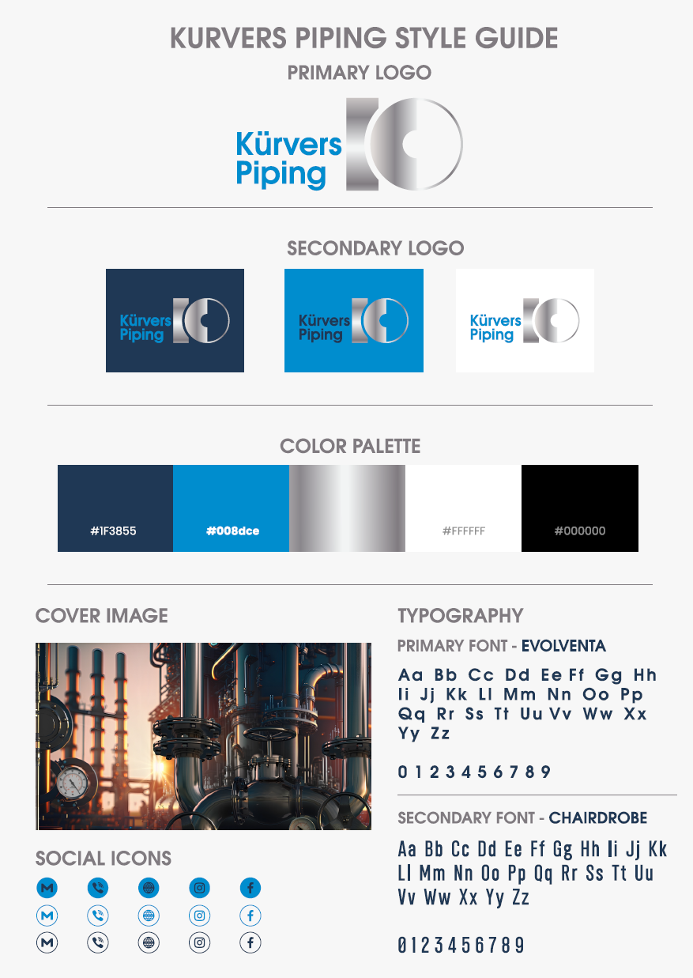

**Site Map**

**Page 1: Home**

* About Us
* Global reach
* Going Green
* Scrolling numbers
* Product range

**Page 2: About Us**

* About Us
* Why Us

**Page 3: Turnkey Solutions**

* Turney Solutions
* Unrivalled quality

**Page 4: Product Range -Page 4 in Company profile**

* Pipes
* Plates, Beams and Profiles
* Fittings, Flanges, Gaskets, Bolts, Nuts, Weld Consumables
* Valves, Strainers, Traps

**Page 5: Careers**

**Page 6: Contact Us**

**Footer:**

**www.kurvers.com**

**Page 1 – Home**

**Kürvers** wants to have scrolling images

They want to lead with an image of going green

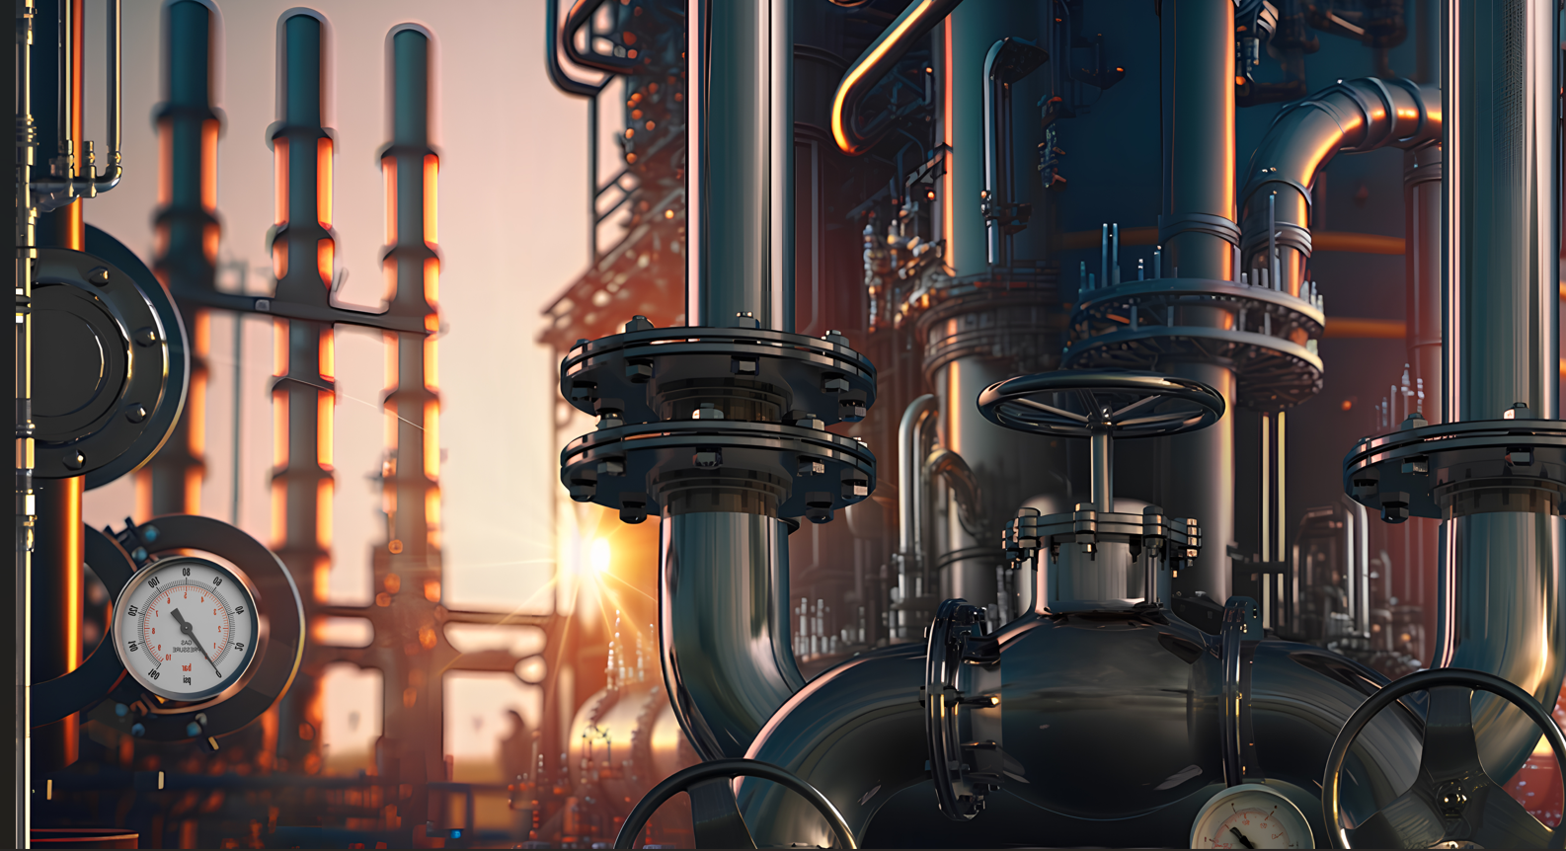



**Tagline: Your partner for success Process Piping, Offshore, Pipelines**

**Icon:**

**Celebrating 55+ years of service**

(can we make this like an icon that sits in right hand corner)

**Intro**

**55+ Years of Excellence in Pipeline Projects**

Founded in 1966 in Düsseldorf, Kürvers is a global leader in the procurement of materials for complex pipeline projects in petrochemical and energy sectors. Our extensive experience, industry expertise, and long-standing partnerships ensure unmatched reliability and delivery.

We prioritise **quality,** **transparency, integrity, and collaboration**, going beyond expectations to solve challenges and meet your requirements.

Let us be your trusted partner in delivering world-class solutions for your projects.

**Global Reach**

Our headquarters in Germany maintain close collaboration with strategically positioned offices and agents across key global markets. This extensive network enables us to offer localised expertise, cultural understanding, and direct engagement, ensuring seamless management of projects and adherence to deadlines. Supported by centralised leadership and a unified approach, we deliver premium, tailored services to clients worldwide.

**Going Green: Reducing our Carbon Footprint**

At Kürvers, sustainability is integral to our operations as we actively work towards reducing our carbon footprint. We are committed to adopting innovative practices such as carbon capture technologies to minimise emissions across our supply chain and manufacturing processes.

Additionally, we are optimising our workspaces by reducing office sizes which not only reduces energy consumption and resources but also promotes a greener, more efficient business environment.

**Dynamic scrolling numbers**

Established 1966

Projects completed 3000+

Locations worldwide 9

**Product Range**

* Pipes
* Plates, Beams and Profiles
* Fittings, Flanges, Gaskets, Bolts, Nuts, Weld Consumables
* Valves, Strainers, Traps

**Page 2 – About Us**

**Breakout box**

**A legacy of excellence for a modern world**

We go the extra mile for every customer, delivering first-class turnkey solutions on a global scale, achieving sustainability through efficiency and excellence**.**

**About Us**

Founded in Dusseldorf in 1966, Kurvers is an international operating group of companies and a proven specialist for pipeline projects int the petrochemical and energy industries.

With over 55 years of experience, we excel in procuring materials globally for complex projects, ensuring unmatched delivery through trusted supplier relationships. Our commitment to reliability, integrity, and collaboration, drives us to exceed expectations and meet every client's unique project requirements.

**Why Us** – refer to page 5 of the company profile

**Excellence**

Kürvers staff have an impressive 1000+ years of a accumulated industry experience and relationships with the leading manufacturers, stockists and service providers worldwide.

**Quality**

Is at the forefront in everything we do. it's our absolute priority, providing you with the highest quality in products and services. Kurvers has been ISO 9001 :2015 certified since 1990.

**Experience**

With 3000+ completed projects since its foundation in 1966, Kürvers has a thorough understanding of the critical requirements for successful piping & steel supplies.

**Integrity**

Dedicated teams ensure seamless project management so that our clients can focus on their tasks.

**Collaboration**

Kurvers operates globally with a far-reaching supply network. We are always close to our clients, providing unrivalled, personal service wherever they are.

**Customer Focus**

We are dedicated to our customers. We listen and understand their needs, forging life-long partnerships and ensuring exceptional delivery through flexible, tailor-made solutions.

*Use the same Icons as the Company profile

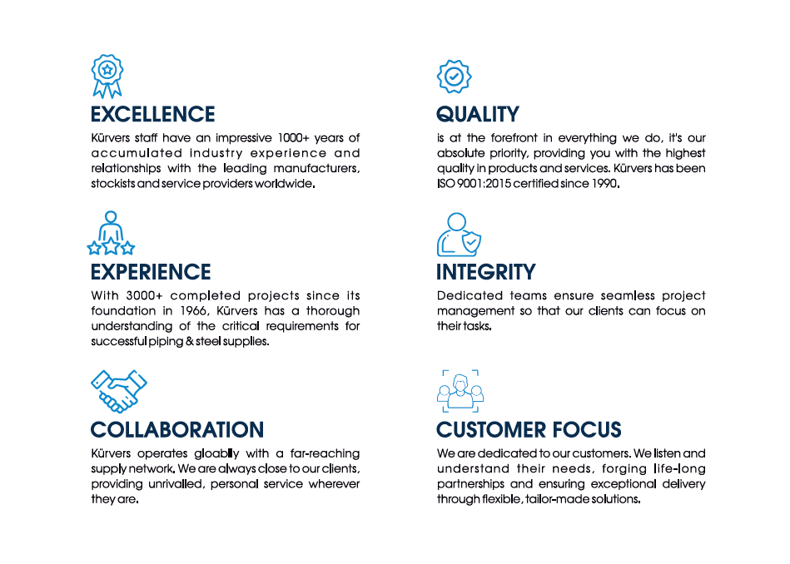

**Page 3: Turnkey Solutions**

We deliver comprehensive turnkey solutions with a commitment to excellence, ensuring all aspects of your project are executed successfully.

We developed a computer-supported network management system, certified to ISO 9001 standards, that guarantees all stakeholders have timely access to essential data. Additionally, our employee training programs ensure that knowledge and expertise from diverse projects are shared across our organisation, equipping our team with expert knowledge across core competencies and are able to support you in all matters.

**Breakout Box**

**“We deliver comprehensive knowledge, a trustworthy supplier network, and extensive industry experience acquired over more than 55 years.”**

**Unrivalled Quality**

**Your Success is Our Success**  
At Kürvers, quality has always been our top priority, even before the implementation of quality management systems and ISO 9001 accreditation. We recognise that delivering only the highest quality products and services ensures the successful completion of our clients' projects. Our commitment is to provide these exceptional products and services consistently.

**Page 4: Product Range -Page 4 in Company profile**

* Pipes
* Plates, Beams and Profiles
* Fittings, Flanges, Gaskets, Bolts, Nuts, Weld Consumables
* Valves, Strainers, Traps

**Page 5: Careers**

**Kürvers Piping offers worldwide opportunities**

Kürvers Piping and its international network offers various job opportunities.

If you want to join our Team, please send your application to [job@kurvers.com](mailto:job@kurvers.com)

**We are hiring https://www.kurvers.com/careers**

**Our Dubai office is looking for dynamic professionals:**

[**>> Accountant**](https://www.kurvers.com/fileadmin/user_upload/Horst_Kuervers_GmbH/PDFs/2022-10-07_Accountant_JD.pdf)

[**>> Document Controller**](https://www.kurvers.com/fileadmin/user_upload/Horst_Kuervers_GmbH/PDFs/2022-10-07_Document_Controller_JD.pdf)

[**>> Project Coordinator**](https://www.kurvers.com/fileadmin/user_upload/Horst_Kuervers_GmbH/PDFs/2022-10-07_Project_Coordinator_JD.pdf)

[**>> Senior Project Coordinator**](https://www.kurvers.com/fileadmin/user_upload/Horst_Kuervers_GmbH/PDFs/2022-10-07_Senior_Project_Coordinator_JD.pdf)

**Page 6: Contact Us**

Can we use the map in the Company profile 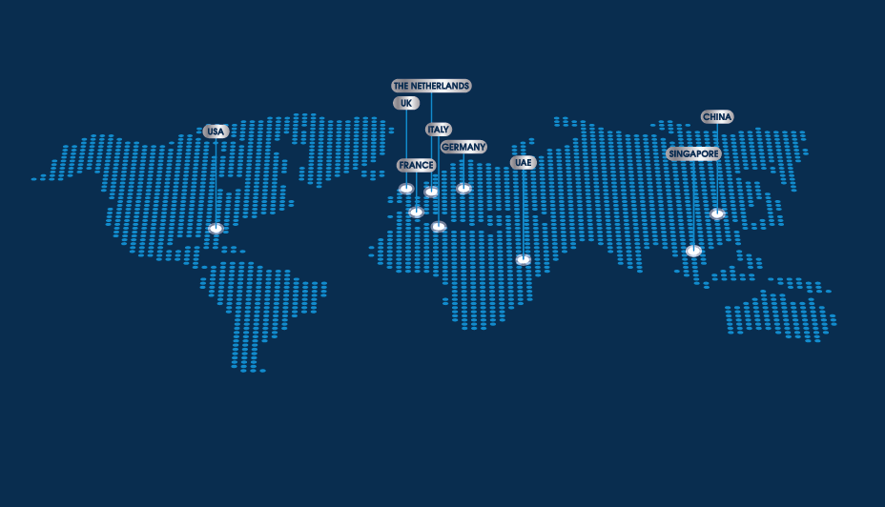

When you hover on each location you get the contact details

